Score | Overall Impact of the  Display  (Use of space, dimensions of  question, readability, neatness,  and creativity of the report design aspects) | Technical Aspects  (Spelling, Grammar, Consistency  of colors or patterns) | Clarity of the Message  (Can anyone not involved in this class get the message) | Graphic display  (graph is readable and clearly interpretable)
4 | Report is neatly constructed,  including good use fonts,  pictures, and extras. The overall  display is eye-catching but  retains statistical substance.  Good use of space for graphical  presentation. Addresses multiple  dimensions of the question or  problem. | Report uses colors and patterns  well. Correct grammar and  spelling are used. | Question or purpose is clearly stated, and the presentation leads  to the conclusion on a path that is easy to follow. The results of the study are immediately obvious to  the viewer. | Scatterplot is clearly labeled and points are defined.  No mathematical errors.
3 | Addresses multiple dimensions  of a question. Good use of  space. Fonts could be larger but  do not really detract from the  message. Could be a little neater  but really does not detract from  the message. | Better use of color or patterns would help the presentation, but  in general the report grabs the attention of the viewer. Correct grammar and spelling are used. | At least one link in the chain  from the question through the  results to the conclusion is  difficult to follow | Errors or inaccuracies are present  in at least one instance.
2 | Good use of space. Addresses  multiple dimensions of a  question. Readability or neatness  detract from the overall appeal of  the report. | Use of more or different colors, would vastly improve the appeal  of the report. Minor grammar and/or spelling mistakes. | The progression from question to  conclusion can be followed, at  least in part, but only with  considerable effort, and the  information on the back may be  needed to confirm. | 2 or more errors in scatterplot are detected
1 | Serious problems with neatness  or organization prevent the report  from being eye-catching and  understandable. Multiple  dimensions of the question  addressed. Could use space  better. | Serious problems colors or  patterns prevent the report from being eye-catching and  understandable.  OR Multiple mistakes in  grammar or spelling prevent the report from being eye-catching and understandable. | The information on the is difficult to be  understood
0 | The report is unidimensional.  Poor use of space for graphics.  Major neatness or readability  issues. | The report is has multiple  spelling or grammar/spelling  errors AND isn’t consistent with colors or patterns so much so that it severely distracts from the  report. | The report is virtually  incomprehensible. | 3 or more errors in scatterplot are detected
Score

5 points will also be added for meeting all 6 requirements.
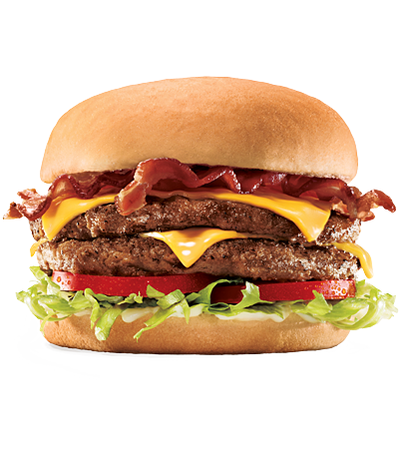
Unit 4 assessment: Report 1-2 pages or
PowerPoint with a minimum of 8 slides. 20 points

Your mission: Predict the number of calories in the Super Sonic 2/3 pound Double Bacon Cheeseburger, which has 87 grams of fat.
Is the amount of fat in a burger, or other sandwich, a good predictor of the amount of calories?

Your report should contain:
- A scatterplot (with StatCrunch) of the data with clear labels and scales, including a description and conclusion.
  - Use the correlation coefficient r to support your conclusion.
- Find the LSRL(equation of the least squares regression line, using StatCrunch) that fits the data and drawn on the scatterplot.
  - Interpret the slope and y-intercept in context to the problem.
- What percent of the variation in calories can be accounted for? (find and interpret 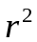)
- Make your prediction and estimate the amount of error you expect
(i.e. find and interpret the value of )
- Complete the table to include the expected number of calories for each sandwich and the residual calories in each sandwich.

The following table below shows some the fat/calorie content of some popular McDonalds’ sandwiches and 1 BK sandwich.

Use the data to make your prediction.
Sandwich | Total Fat (grams) | Total Calories | Expected Calories | Residuals
Hamburger | 8 | 250
Cheeseburger | 12 | 300
Quarter Pounder with Cheese | 21 | 420
Double Quarter Pounder with Cheese | 27 | 540
Big Mac | 28 | 540
Double Cheeseburger | 22 | 430
McDouble | 18 | 390
Whopper | 35 | 630
Bacon Clubhouse Crispy Chicken Sandwich | 39 | 650
Premium Crispy Chicken Classic Sandwich | 22 | 510
McRib | 26 | 500

